**Put each figure on a separate page**

*Please read carefully the instructions for authors to know the number of figures allowed and figures characteristics.*

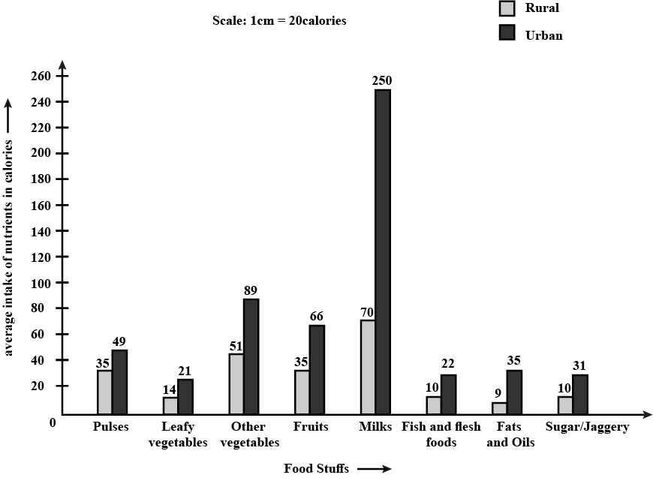

**Figure 1.** Title of Figure 1 (with high resolution) please see the instructions for authors.